6

Analyses of Components with Solid Elements

Exercise 1

* Create the spring’s helical coil profile.
  + The following parameters are used (notice that the free length is maintained at 500 mm as specified in the question):

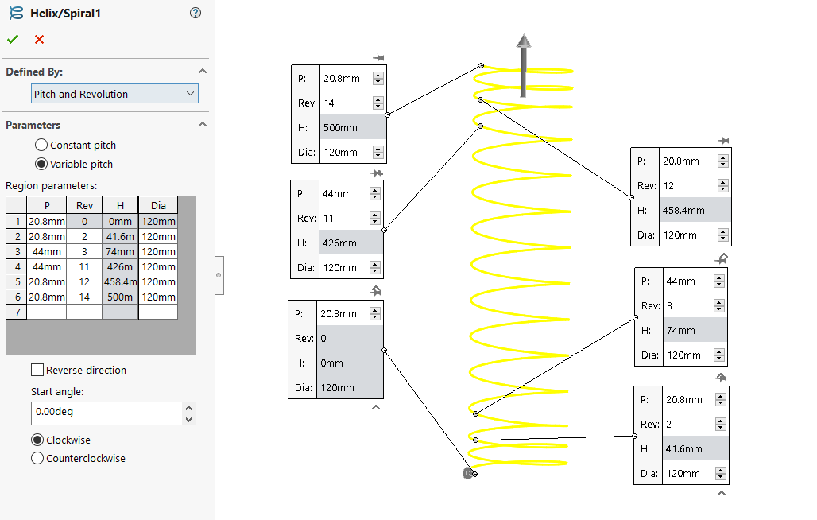

* Complete the springs model using the sweep profile and then add the end treatment

|  |  |  |
| --- | --- | --- |
| With no end treatment | Completed with the end treatment | End-treated spring with base/load supports |

* Complete the simulation study
  + Define and apply the Music Wire A228 material properties
    - See e.g. [A228](https://www.matweb.com/search/datasheet.aspx?matguid=4bcaab41d4eb43b3824d9de31c2c6849&ckck=1)
  + Apply the necessary fixture (symmetric boundary conditions using the **Reference Geometry Option**)
  + Apply the external load of 300 N
  + Run the study to get the solutions/results
    - A plot of the distribution of the deflection is shown below:

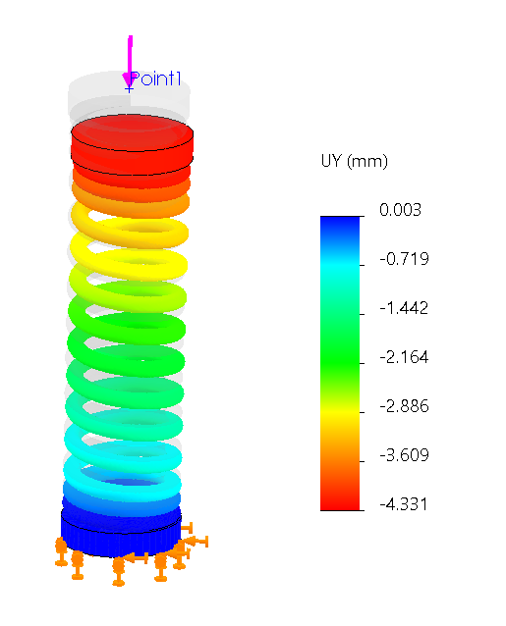

* Use the **Probe** tool to obtain the average value of the deflection (away from the support and the boundary condition as:

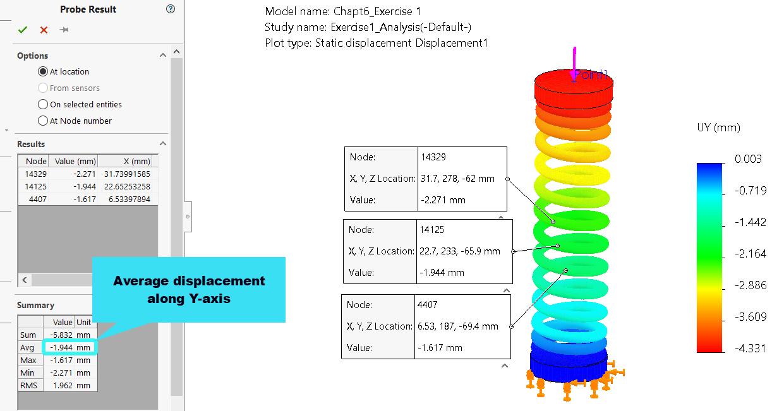

As can be seen from the above image, the average value of the vertical deflection is $1.944 mm$ (in absolute term). The accuracy of this value can be verified using the following equation:

$y=F/k$, where $k=\frac{d^{4}G}{8D^{3}N_{a}}$

where:

* $d=$ wire diameter $=20 mm$
$G=80 GPa$

* $D=$ mean diameter $=$ Outer diameter (120 mm) – wire diameter (20 mm) = 100 mm

$N_{a}=10$

By using the above values in the equation, we obtained $y=1.875 mm$, which is not too far from the average value of $1.94 mm$ predicted by the simulation.

Exercise 2

The Q2a exercise deserves a remark. If you are using an earlier version of SOLIDWORKS (say, 2020-2021), the basic linear static analysis can be easily accomplished for the case with a friction coefficient of *0.02*.

However, if you are using the newer 2021-2022 version, you may encounter a challenge with the convergence of the solution and the solution time will be annoyingly long. In order to avoid this frustration, it is advisable to solve the exercise with the non-linear solver. Here are the steps:

* Form a new study from the previous solution as shown below:

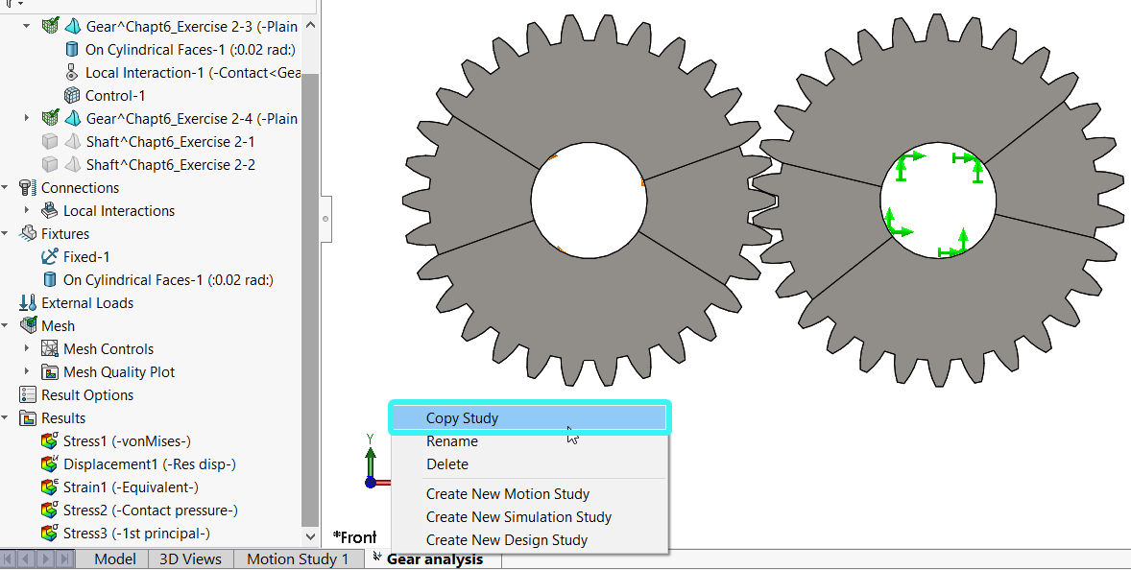

* + In the Copy Study property manager that appears:
    - Provide a name for the new study
    - Click on the **Nonlinear** study Option (see below)

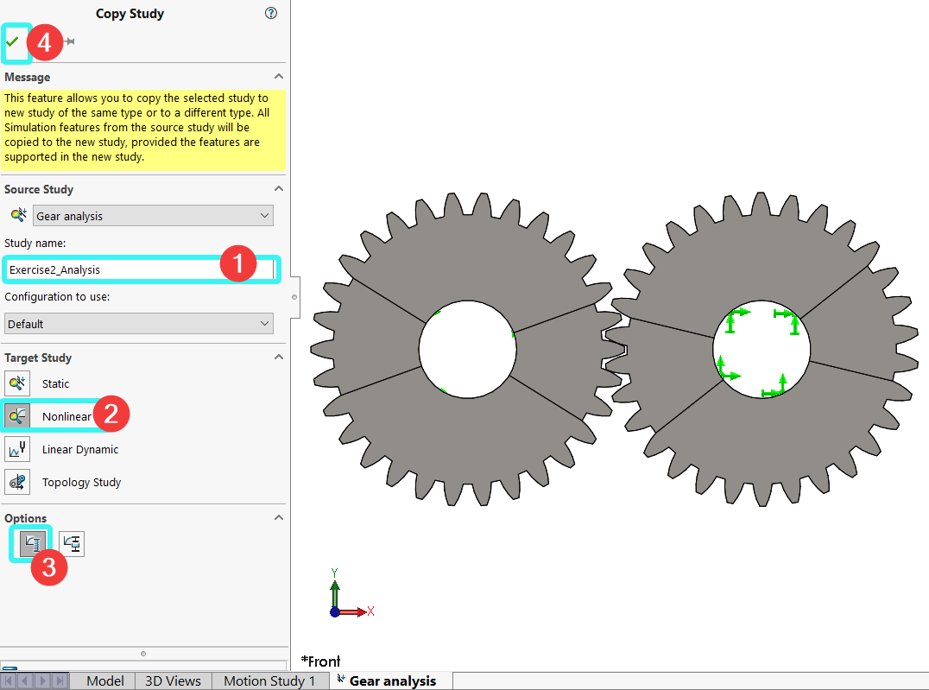

* + Examine the nonlinear study Property options by:
    - Right-clicking the study name as shown below:

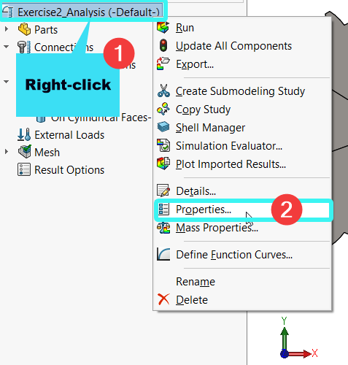

* + - Observe the options, but you don’t have to change anything:

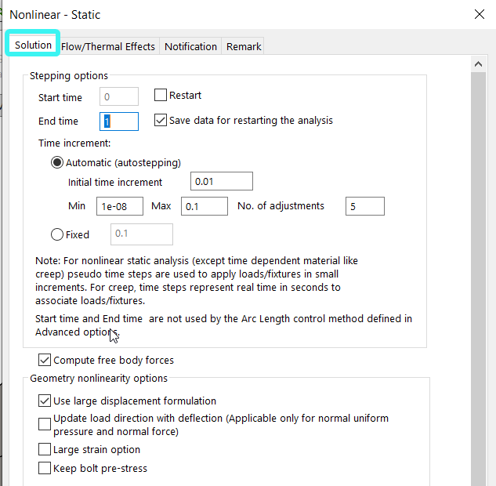

* + Update the Local Interaction parameter as follows:

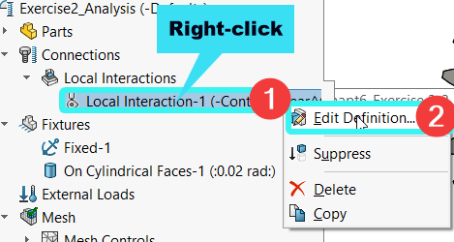

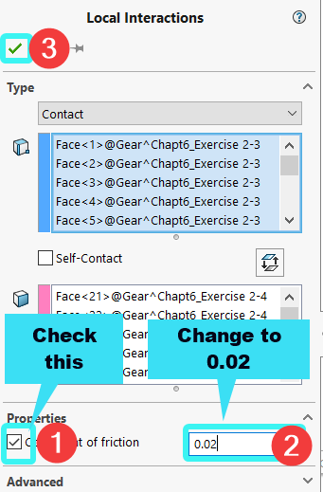

* Run the analysis and obtain the results.
  + During the running, you may obtain the following warning, select OK.

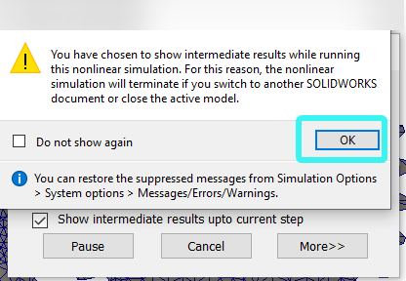

* + During the running of the analysis, the following solution progress window will be up so you can monitor the solution until completion.

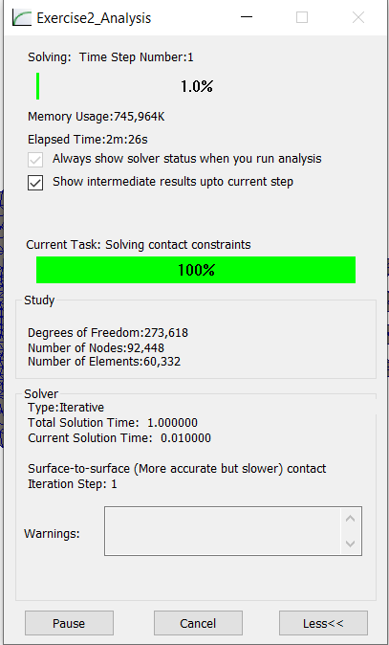

* + **(2a) von-Mises stress distribution with friction coefficient of 0.02**

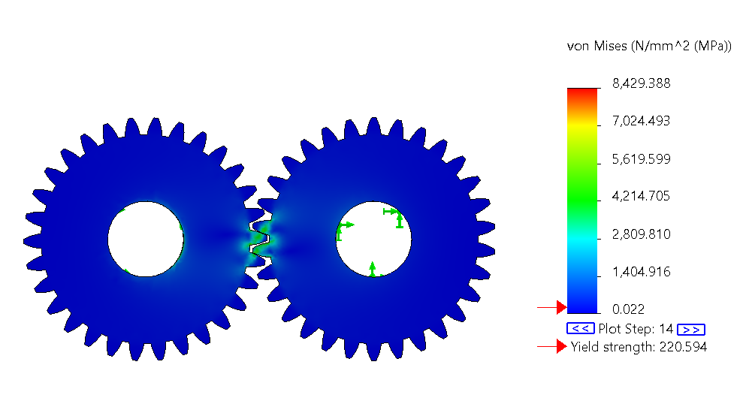

**NOTE**: As indicated within the chapter, the loading condition and the stress distribution are used for illustrative purpose only. A more realistic gear stress analysis will likely follow a different workflow in terms of the boundary condition and applied load.

* + **For the solution to Q(2b):** The von-Mises stress distribution with the default global bonded interaction is obtained with no friction coefficient by: (i) copying the original study; (ii) deleting then replacing the local interaction condition with the global bonded interaction condition. The distribution of the stress is obtained as follows.

